Maharashtra:

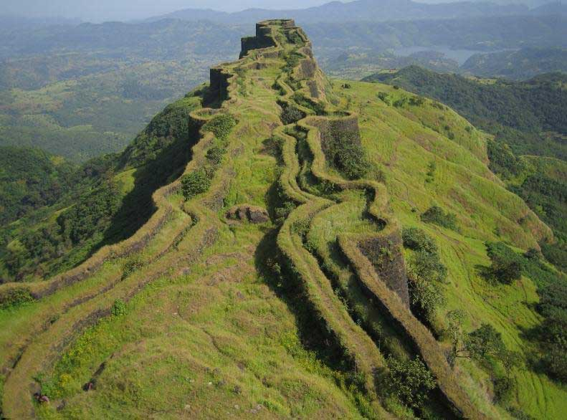

History :

https://www.maharashtratourism.net/history.html

Famous tourist places in maharashtra

<https://www.trawell.in/maharashtra/best>

Famous food in Maharashtra

<https://food.ndtv.com/lists/10-best-maharashtrian-recipes-695953>

Famous shopping things in maharashta

<https://www.tourmyindia.com/states/maharashtra/shopping.html>

Gujarat:

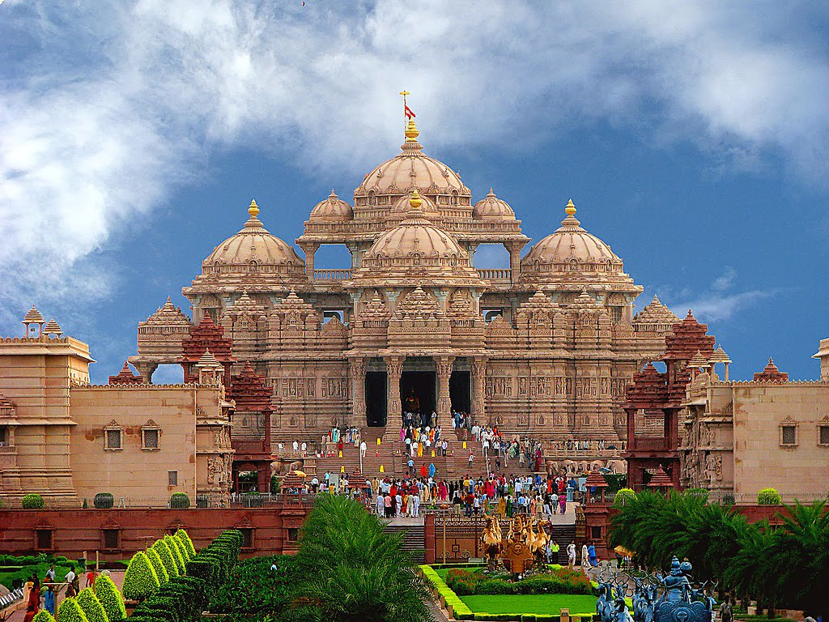

History:

https://gujaratindia.gov.in/about-gujarat/history-1.htm

Famous tourist place in Gujarat:

<https://www.tripsavvy.com/top-attractions-and-places-in-gujarat-1539326>

Famous food in Gujarat

<https://food.ndtv.com/lists/10-best-gujarati-recipes-695837>

Famous shopping things in Gujarat

<https://www.swantour.com/blogs/shopping-places-in-gujarat/>

Punjab:

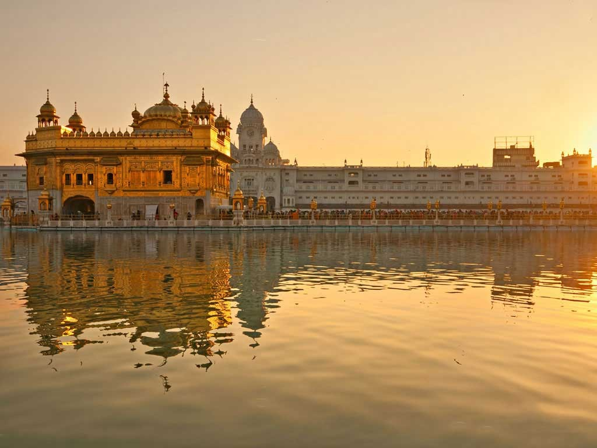

History:

https://punjab.gov.in/know-punjab/history/#:~:text=The%20Indian%20State%20of%20Punjab,part%20became%20India's%20Punjab%20state.

Tourism:

<https://traveltriangle.com/blog/places-to-visit-in-punjab/>

food

<https://food.ndtv.com/lists/10-best-punjabi-recipes-724174>

shopping

<https://lighttravelaction.com/best-punjab-souvenirs-to-pick-patiala-amritsar/>

Tamilnadu:

History

<https://www.tn.gov.in/tamilnadustate#:~:text=The%20State%20of%20Tamil%20Nadu,and%20the%20Pandyas%20for%20centuries>.

Assam:

History

<https://assam.gov.in/en/main/Assam%20History>

Himachal Pradesh:

History

<https://www.britannica.com/place/Himachal-Pradesh>